Assignement 1

Task-1

Making full screen for centos machine

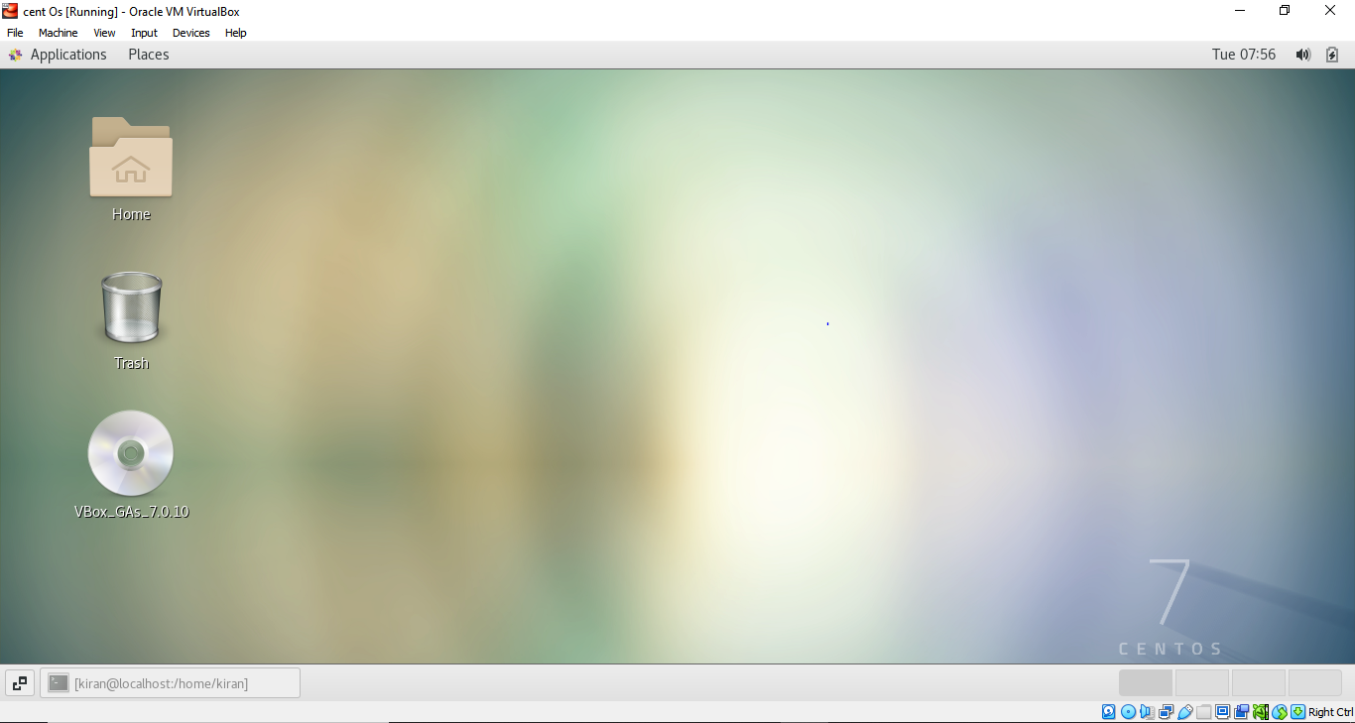

Task-2

Update the centOS machine

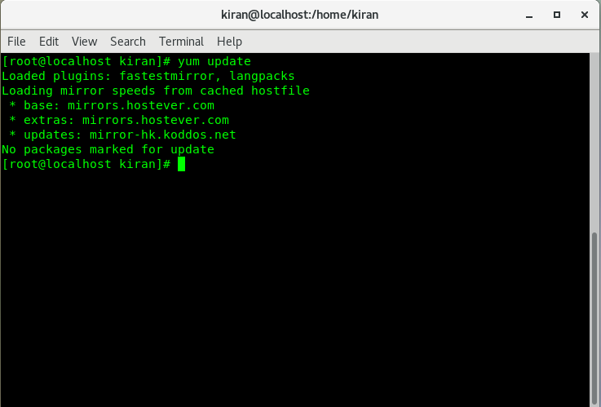

Assignment – 1

Login to non-existent user

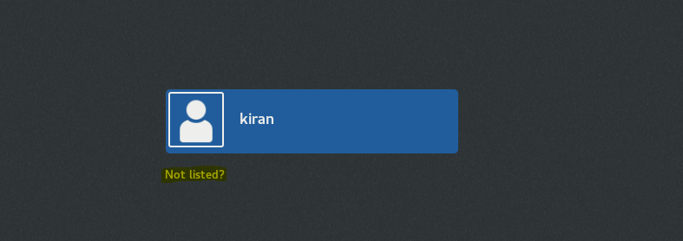

Lol is not a user in this machine

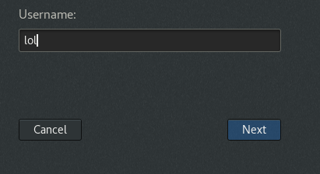

Trying to log in to the lol account with some password

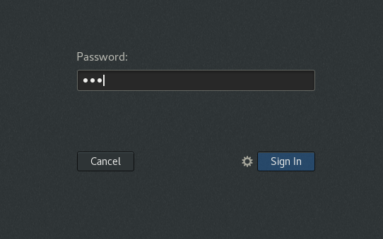

Throwing an error message to login

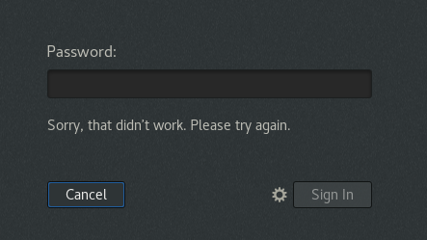

Trying to login to another non-existent use in the terminal



Assignment -2

Password change

Updating the user lol password to ***IneuR0n#42***

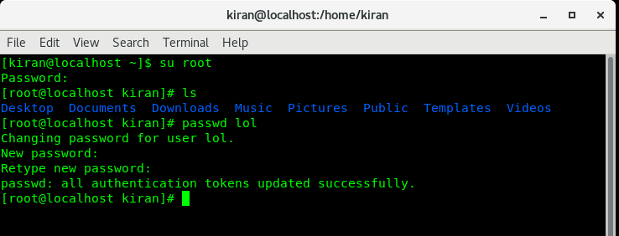

Initially I was not able to login to the lol account using my old password but able to login with this password ***IneuR0n#42***

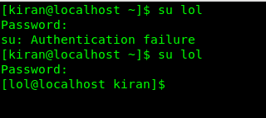

Trying to change the password to abcd or 1234

Throwing the below error

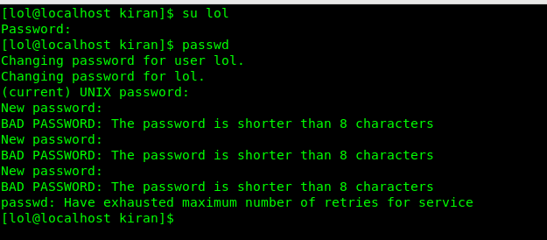

Trying to change the password but this time not updating any password

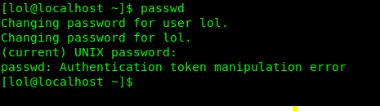

Assignment-3

Working on directories

Trying cd / then ls, this shows the system architecture of the centOS, where

* /bin – folder contains all the binary files
* /boot – folder contains all the bootable files that is used while starting the linux machine
* /etc – where This was mostly used as a catch all for files that did not meet the categorical requirements to be placed in the other default directories like /bin, /dev, /lib, and /usr
* /dev -  is a directory that stores all the physical and virtual devices of a Linux system
* /home – where all the user directory will be created
* /media – will have the details of the removable devices
* /mnt – for temporary mount point
* /opt -  reserved for the installation of add-on application software package
* /proc -  show information about the memory usage and statistics of a Linux system
* /root - is especially for only root user
* /run – contains the contents of the directories and files that are used by the running process
* /sbin - This is used for trivial binaries used in the very early boot stage or ones that you need to have available in booting single-user mode
* /sys – it contains the system file and also provides the information of devices like whether it's powered on, the vendor name and model, what bus the device is plugged into, etc. It's of interest to applications that manage devices
* /tmp - it used as a temporary file where all the user and non-user will have all the privileges
* /usr – where user-land programs and data are present
* /var – where it contains the contains files to which the system writes data during the course of its operation



Moved to cd/home and listed down the directories

From the below output it is clearly visible that only the users that created in the linux system that only is present

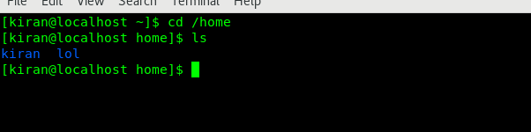

Enter cd ..

From the below output it is clearly visible that the terminal is moved to previous directory



Enter cd /var/www/html

From below image the error says that the directory hasn’t created



Enter cd /root then list down the files and folders

We don’t have the permissions to list down the files only root and sudoers will have the permission to access the file

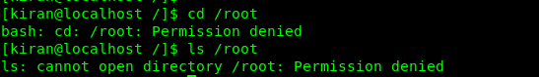

Assignment-4

Working with file listing

Go to cd /etc and list down the file

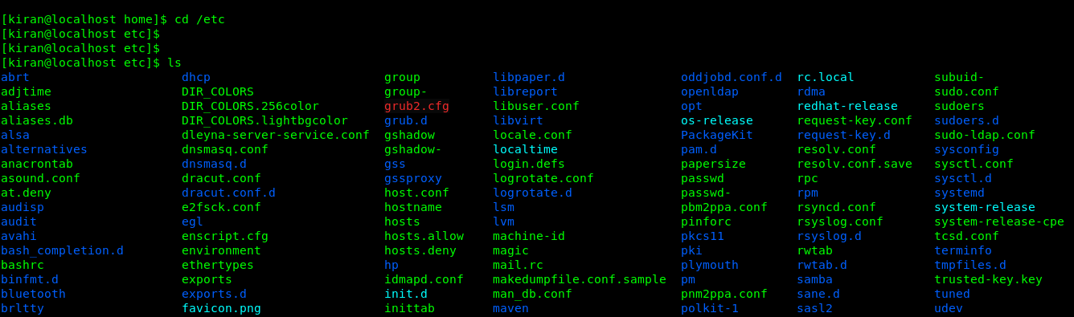

Enter ls -al

Prints out all the files and folders in the list format

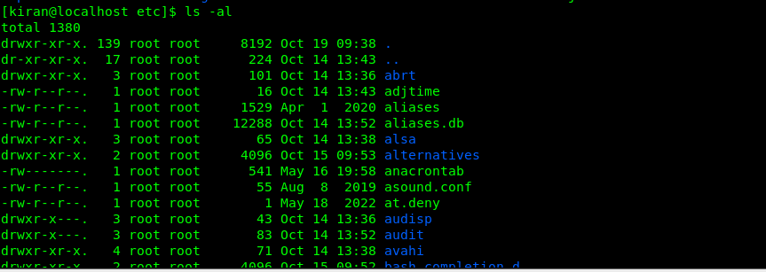

Enter ls -i

Prints the inode of each file in the directory

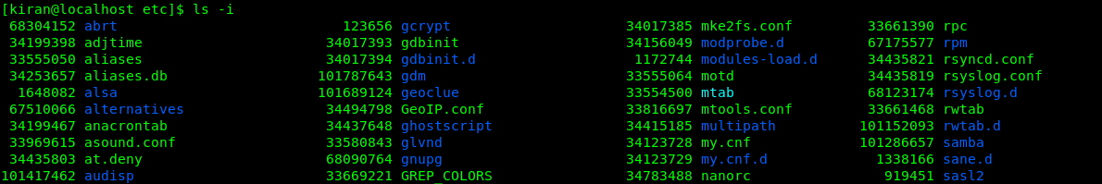

Enter ls -help

Prints out the list of flags that can be used for ls command

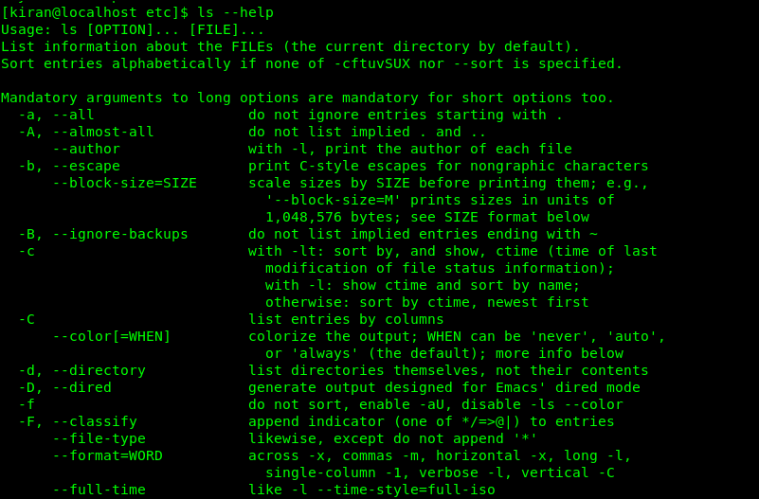

Assignment-5

Open terminal after restart, enter the command pwd

Prints the present working directory in the terminal



Enter cd /var, then list down the files and folders



Other commands

* dir
* grep
* sort
* uniq
* tee
* echo
* awk
* tr
* sed